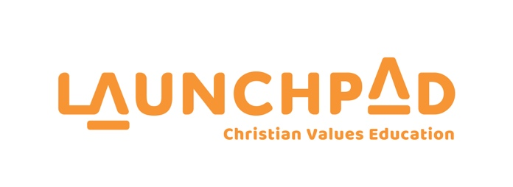

CHURCHES EDUCATION COMMISSION REPORT
TO THE GENERAL SYNOD / TE HĪNOTA WHĀNUI 2023/2024

23 February 2024

Report to the Anglican Church of New Zealand

On behalf of the Churches Education Commission, I want to thank you for your continued support to us. Your contribution of funds and the provision of volunteers throughout our schools in Aotearoa makes it possible for this work to continue.

We have been grateful to have been able to continue to walk alongside students during this past year.

The original mandate of CEC was “to stimulate service and co-ordinate member churches for Christian education in New Zealand.”

We view CEC as a bridge between the local church and local community, with our purpose to serve both, in order to further advance Christian education. CEC has now served the church and the local community for 127 years.

The partnership of the Anglican church with the Churches Education commission allows thousands of children throughout Aotearoa to attend a Launchpad class and hear the message of hope, truth and love. We are extremely grateful to God for your ongoing partnership and support.

Schools
The demand for Launchpad in schools remains strong. The opt in system allows parents the decision to decide if this is something they want for their children. Some schools that have decided to cease the programme in the past have recommenced due to the demand from parents for the programme.

The disruption to schools during the covid lockdown years was significant with many schools being slow to open to us again, but gradually most schools on our books have recommenced the Launchpad programme.

Curriculum
During the past 12 months we have we have further refined and enhanced our curriculum with the addition of a new booklet containing 25 New Zealand history stories. Our facilitators can choose to use these stories in their Launchpad classes throughout the year.

Schools are appreciative of these lessons as it assists them with the recent mandate by the Ministry of Education to teach New Zealand history at a primary school level.

Regions
This past year we have been focusing on helping our less performing regions who are struggling. CEC has 15 regions, and we are conscious that our strength lies in the sum total of the performance of each region.

We also remain focused on recruiting and training more volunteer presenters to take our programmes into schools. Over the past 3 years our number of presenters has significantly reduced which naturally has an impact on our programmes.

Ongoing training for all our Presenters is also something we invest time and resource into. It is increasingly important in today’s school environment that the quality of our lessons remains high.

Auckland Prayer Breakfast
It was an honour to be a key sponsor of the Auckland prayer breakfast 2023 which included the opportunity to have a strong presence at the breakfast with a booth, promotional material at each place setting and our promotional video being played during the main presentation.

New Zealand School Trustees Association
We were again privileged to attend the NZSTA conference in June 2023. The conference was attended by nearly 1000 school board trustees and Principals from across the country. We had incredible conversations across the 3 days with a significant number of Board Chairs and Principals registering interest in commencing the Launchpad programme at their school.

Prayer
Prayer is always at the forefront of our needs. We are grateful for those of you who bless us in this way and encourage you to continue.

As a result of Launchpad and Lifewalk being able to exist in schools we impact the lives of thousands of children per year

Thank you for your part in helping make this possible.
.
We are very grateful for God’s faithfulness and enabling. We know God is weaving the strands of the flax and therefore we can rest in his design and purpose.

Blessings

Geoff Burton

CEO Launchpad
Churches Education Commission

